Jared Raiola

HW1

1/29/20

**NOTE: In advance, I apologize if screenshotting the print pages is not allowed, I believed it would the best way to combine all the information.**

Part 1

1. Three Protocols:
   1. SSDP
   2. HTTP
   3. DNS
2. Time for HTTP GET: 2.81154



1. Internet Address
   1. gaia.cs.umass.edu: 128.119.245.12
   2. My Computer: 128.61.78.183
2. Printed HTTP
   1. GET:

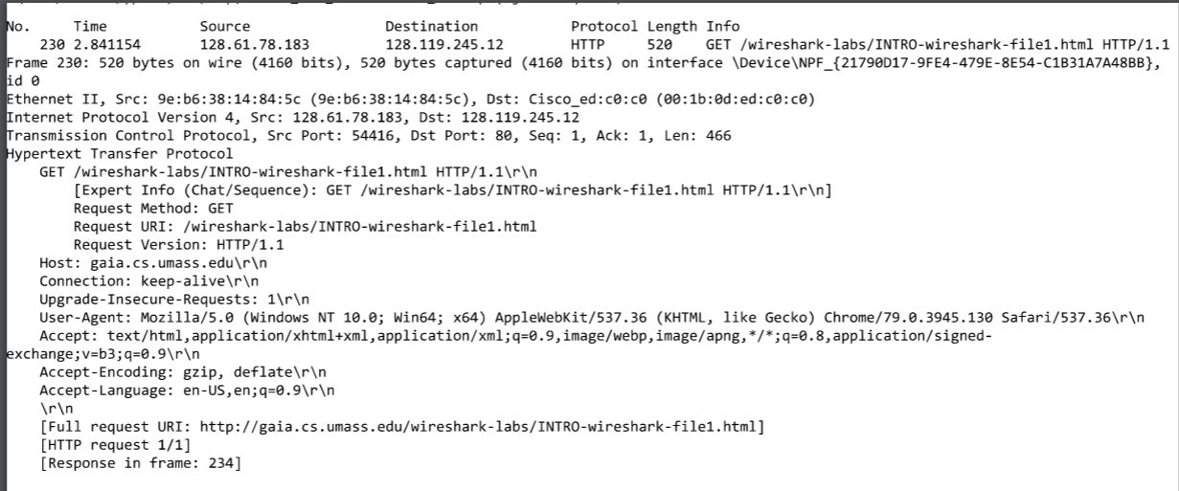

* 1. OK:

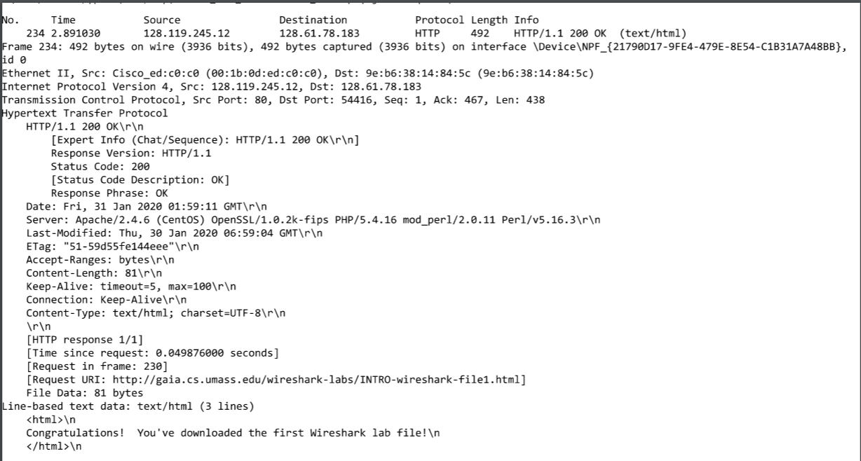

PT 2:

1. HTTP Version:
   1. Browser: HTTP 1.1
   2. Server: HTTP 1.1



1. Language: en-US;en;q=0.9

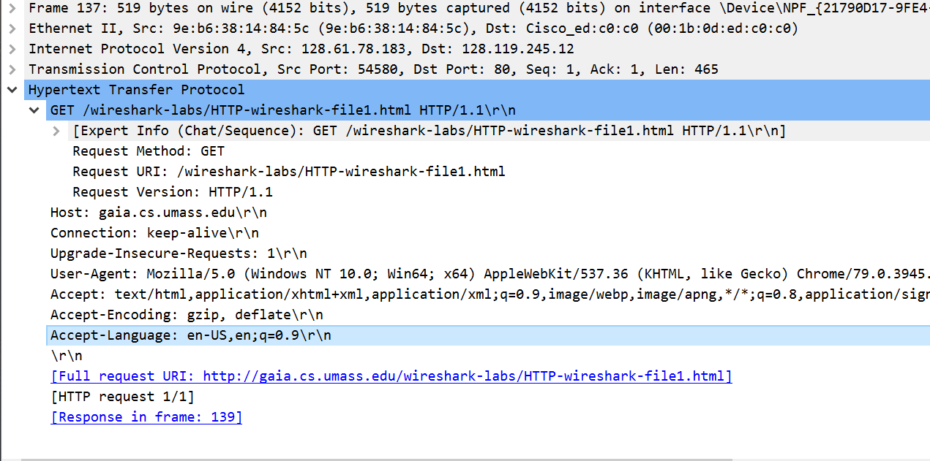

1. IP Address:
   1. Computer: 128.61.78.183
   2. Server: 128.119.245.12
2. Status Code: 200 OK
3. Last Modified: Thu, 30 Jan 2020 06:59:04 GMT

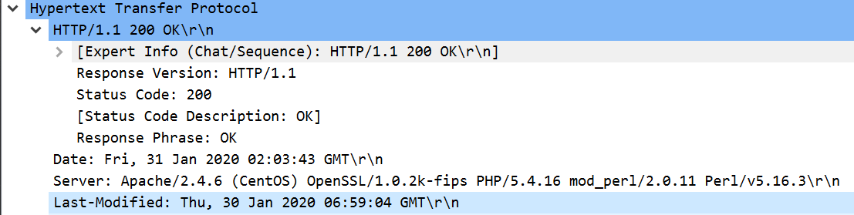

1. Content Length: 128 bytes

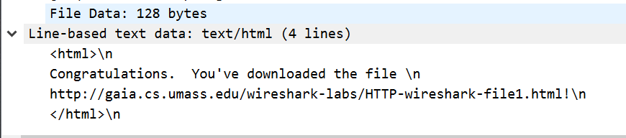

1. No I do not see any other headers not displayed.
2. No IF-MODIFIED-SINCE.

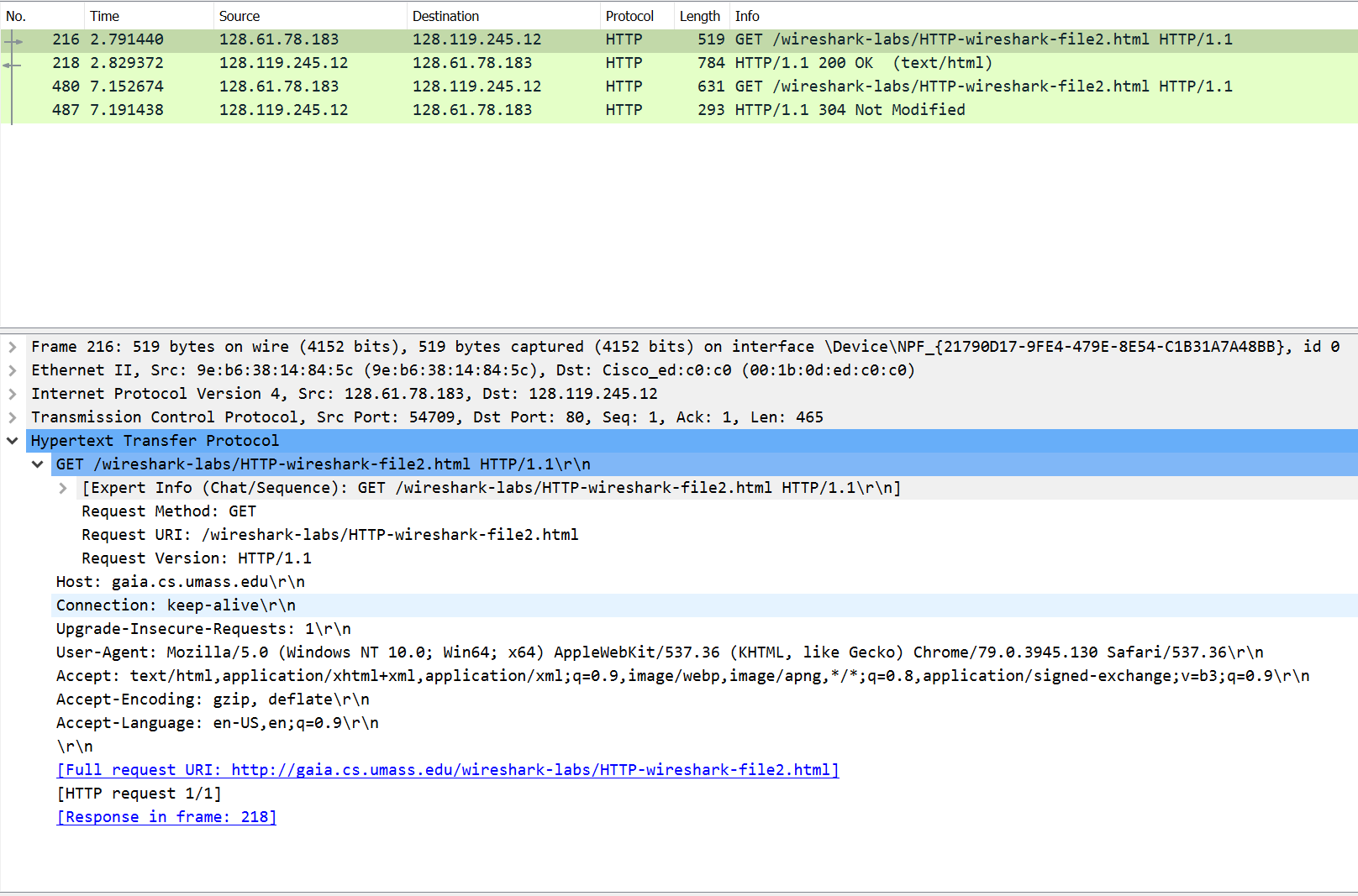

1. The server did return the contents of the file. You can tell by expanding the Line-based text data in Packet Contents of the response, which shows the file contents.

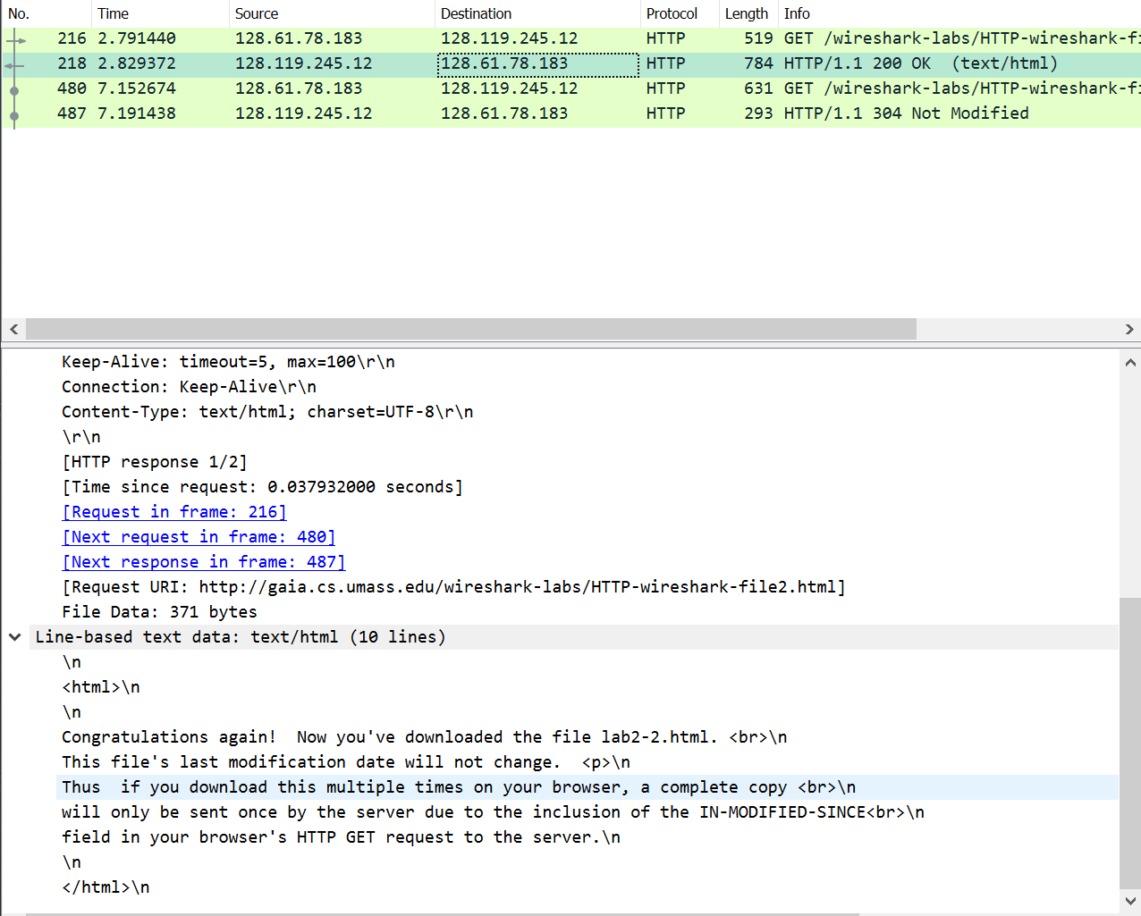

1. Yes, IF-MODIFIED-SINCE is present.
   1. If-Modified-Since: Thu, 30 Jan 2020 06:59:04 GMT\r\n

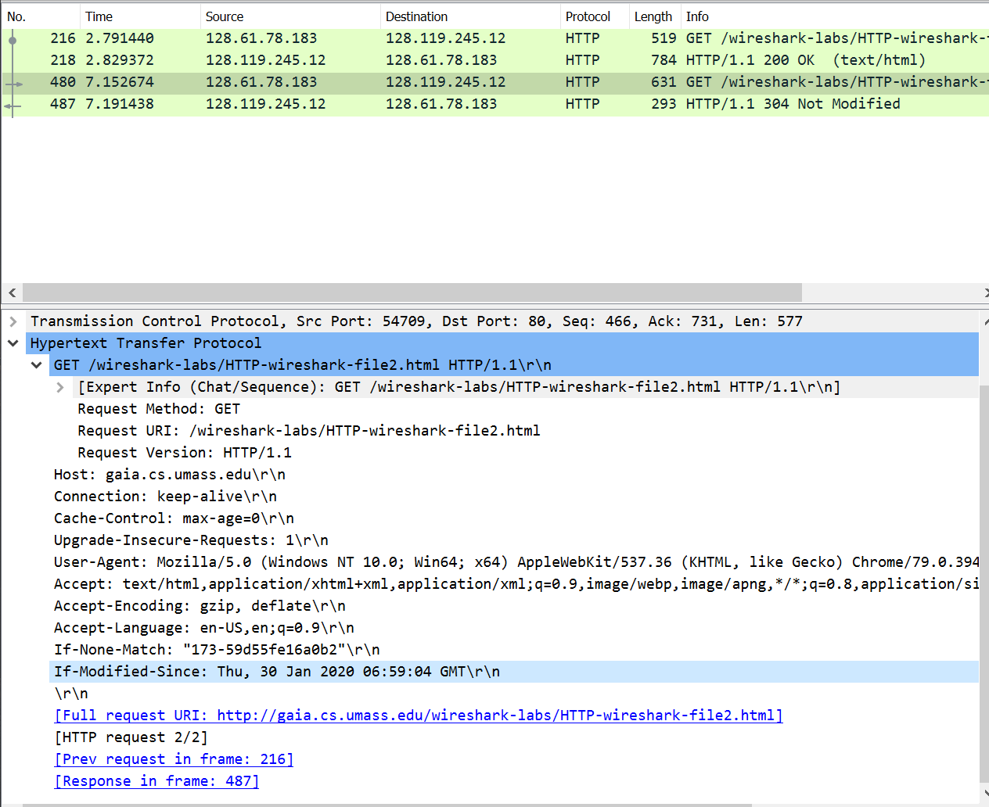

1. HTTP Status Code: 304 Not Modified
   1. We did not receive the full file contents as Line-based text data is not present
2. # of Packet with HTTP GET Requests: 1
   1. Packet # = 338
3. # of Packet with Status Code and Phrase: 343



1. Status Code and Phrase: 200 OK
2. # of data-containing TCP segments: 4 TCP Segments and then they were reassembled.

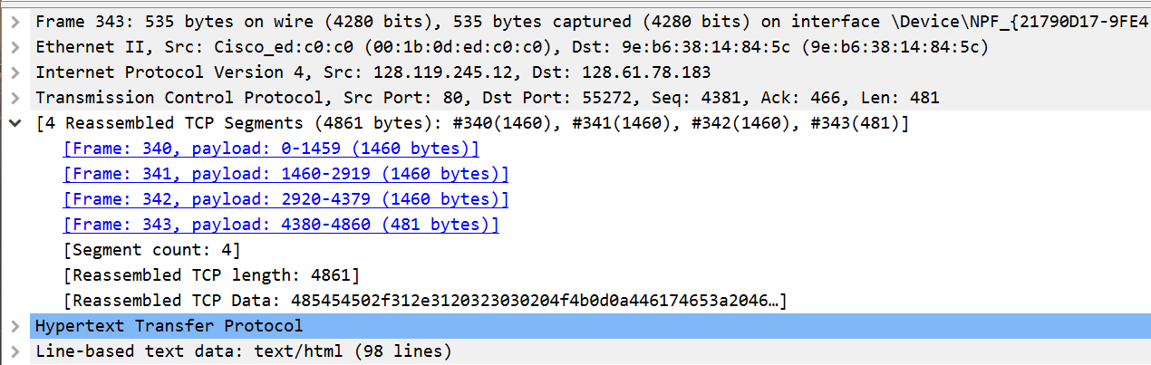

1. # of HTTP GET: 3.
   1. First Request: The first page: 128.119.245.12
   2. Second Request: Pearson Logo: 128.119.245.12
   3. Third Request: Cover of the Pearson Textbook: 128.119.245.12

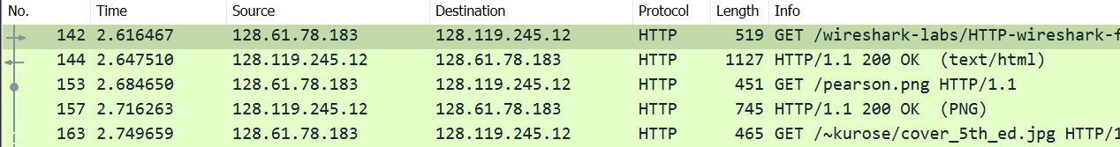

1. The browser downloaded the images serially as the request for the logo was sent and received before the request for the book cover was sent.
2. Status Code and Phrase: 401 Unauthorized

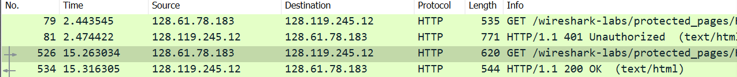

1. New Field: Authorization Field in HTTP Protocol

